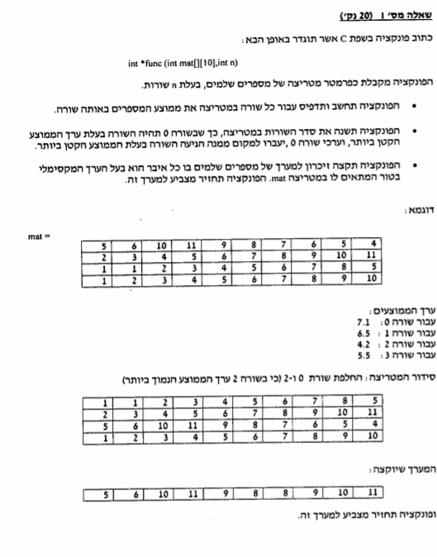

#define n 4

int \*func(int mat[][10])

{

float linesum = 0;

float avgtemp,smallavg=0;

int col, row, temp, smallavgline,i=0;

int \*arr[10];

for (row = 0; row < n; row++)

{

for (col = 0; col < 10; col++)

{

linesum += mat[row][col];

}

avgtemp = linesum / 10;

if (smallavg == 0)

{

smallavg = avgtemp;

smallavgline = row;

}

else if (avgtemp < smallavg)

{

smallavg = avgtemp;

smallavgline = row;

}

printf("average of line %d is: %.1f\n", row, avgtemp);

linesum = 0;

}

if (smallavgline != 0)

{

for (col = 0; col < 10; col++)

{

temp = mat[0][col];

mat[0][col] = mat[smallavgline][col];

mat[smallavgline][col] = temp;

}

}

//insert first array print here....

\*arr = (int\*)malloc(sizeof(int) \* 10);

temp = 0;

for (col = 0; col < 10; col++)

{

for (row=0;row<n;row++)

{

if (mat[row][col] > temp)

temp = mat[row][col];

}

arr[i] = temp;

i++;

temp = 0;

}

//insert second array print here....

return arr;

}

void main()

{

int mat[n][10];

int row, col;

srand(time(NULL));

for (row = 0; row < n; row++)

for (col = 0; col < 10; col++)

mat[row][col] = rand() % 100;

for (row = 0; row < n; row++)

{

for (col = 0; col < 10; col++)

printf("%d|", mat[row][col]);

printf("\n");

}

printf("\n");

int \*ptr = NULL;

ptr=func(mat);

}

//----------------first array print----------

//printf("\n");

//for (row = 0; row < n; row++)

//{

// for (col = 0; col < 10; col++)

// printf("%d|", mat[row][col]);

// printf("\n");

//}

//-------second array print-------------

//printf("\n");

//for (i = 0; i < 10; i++)

// printf("%d|", arr[i]);

//printf("\n");